SS6 Financial Report and Analysis
Wednesday, June 30, 2021
12:28 PM

READING 19. INTRODUCTION TO FINANCIAL STATEMENT ANALYSIS

LOS 21a: Describe the roles of financial reporting and financial statement analysis;
  - Role of financial report is to provide financial information about the reporting entity that is useful to existing and potential investors, leaders, and other creditors in making decisions about providing resources.
  - The ROLE of financial statement analysis is to use the information in FA, along with other info, to make economic decisions. (More about external users, but inner management also performs FA&FR)

B: describe the roles of the statement of financial position (balance sheet), statement of comprehensive income, statement of changes in equity, and statement of cash flows in evaluating a company’s performance and financial position;
  - BS, aka statement of financial position or statement of financial condition, reports the firm's financial position at the time. Assets = liabilities + owners' equity. BS presents a shareholder’s residual claim on assets (residual interests on assets after deducting liability)
  - Statement of comprehensive income reports changes in equity [business activities] except shareholders doing with stocks. Net income determined in the calculation of comprehensive income is a component of the change in retained earnings, but there are other changes that may also have occurred (the payment of dividends, for example) that are not included on the statement of comprehensive income.
  - IS, aka statement of operations or profit and loss statement. Revenues = other Income - Expenses
  - Cash flows: operating, investing, financial

C: describe the importance of financial statement notes and supplementary information—including disclosures of accounting policies, methods, and estimates— and management’s commentary;
  - Footnotes to improve their assessments of the amount, timing, and uncertainty [accounting policies, methods, and estimates] reported:
  - Discuss the basis of presentation, eg fiscal period or inclusion of consolidated entities
  - Accounting methods, assumptions, estimates
(SUMMARY: Business acquisitions or disposals, legal actions, employee benefits plan, contingencies or commitments, significant client, sales or segments)
  - financial instruments and risks arising from financial instruments,
  - commitments and contingencies,
  - legal proceedings,
  - related-party transactions,
  - subsequent events (i.e., events that occur after the balance sheet date),
  - business acquisitions and disposals, and
  - operating segments’ performance
  - Management's commentary aka management's report, operating and financial review, MD&A(discussion and analysis): nature of business, objectives, past performance, performance measures, key relationships, recourses and risk. Maybe unaudited. US SEC requires trends, significant events, uncertainties that affect firm's liquidity, capital resources, operations. Eg:
  - Inflation & price changing
  - Off-Balance-Sheet obligations and contractual obligations - purchase commitments
  - Accounting policies needs judgement
  - Forward-looing expenditures and divestitures

D: describe the objective of audits of financial statements, the types of audit reports, and the importance of effective internal controls;
  - Standard auditor's opinions: 1. independent, 2. GAAS, reasonable assurance of no material errors, 3. accepted and reasonable, with additional explanation. Sarbanes–Oxley
  - Unqualified opinion (clean opinion): no material or errors
Qualified opinion: explains exceptions to the accounting principles
Adverse opinion: not fair or material
Disclaimer of opinion: unable to express opinions in the case of a scope limitation
  - Internal control: process that company ensures it presents accurate FA, responsibility of management. US SEC requires auditors to express opinions on internal control, can separately or 4th element of standard opinion.
  - Auditor:
1. Whereas the financial statements are prepared by management and are its responsibility, the auditor has performed an independent review.
2. Generally accepted auditing standards were followed, thus providing reasonable assurance that the financial statements contain no material errors.
3. The auditor is satisfied that the statements were prepared in accordance with accepted accounting principles and that the principles chosen and estimates made are reasonable. The auditor’s report must also contain additional explanation when accounting methods have not been used consistently between periods.
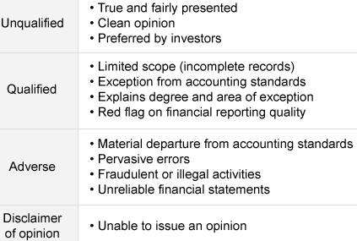

E: identify and describe information sources that analysts use in financial statement analysis besides annual financial statements and supplementary information;
  - Quarterly or semiannual reports (10-Q, 10-K): not audited, but update. 8-K of acquisitions and disposal.
  - Proxy statements: issued to shareholders for voting, about election & qualifications of board members, compensation, management, issuance of stock options
  - Corporate reports, press release: public relations or sales materials
  - Earnings guidance, before FA, a conference all of senior management to answer questions

F: describe the steps in the financial statement analysis framework.
  - State the objective and context
  - Gather data (ask questions about management, suppliers, customers)
  - Process the data (calculate ratios, prepare graphs and common-size BS)
  - Analyze and interpret the data (conclusions and recommendations)
  - Report the conclusions or recommendations (prepare report and talk, comply with code&standards)
  - Update the analysis (aka follow-up, repeat)
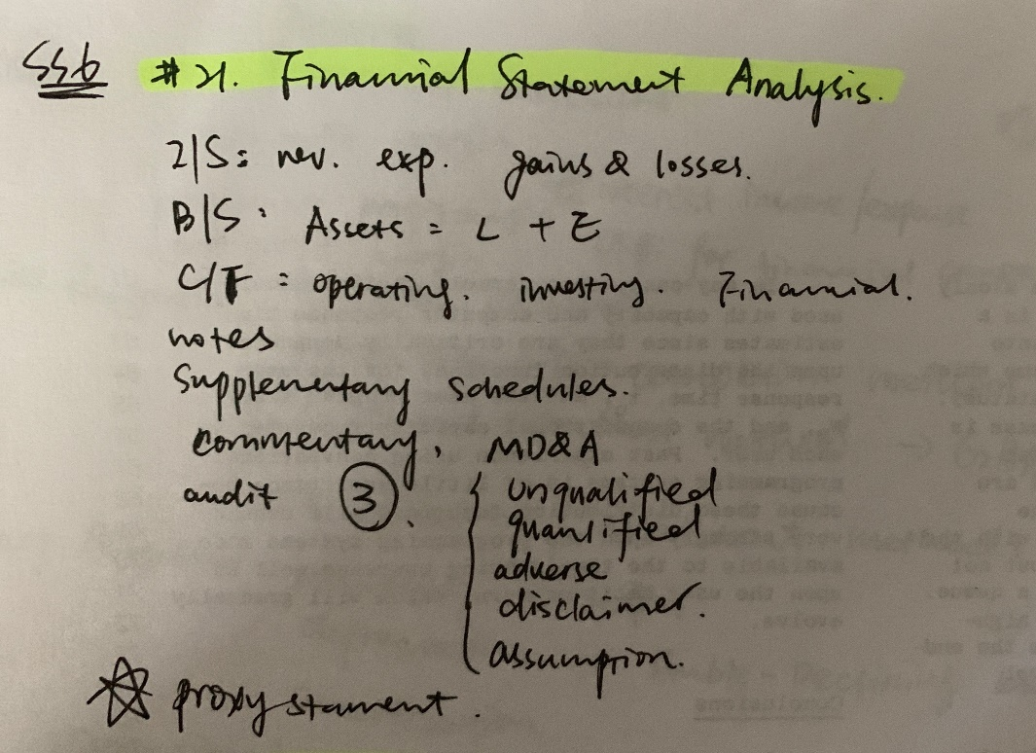

READING 20. FINANCIAL REPORTING STANDARDS

A: describe the objective of financial reporting and the importance of financial reporting standards in security analysis and valuation;
  - To provide economic decision makers with useful info about financial performance and changes in financial positions. Reporting standards ensures diff firms are comparable, narrowing the range of reasonable estimates.

B: describe the roles of financial reporting standard-setting bodies and regulatory authorities in establishing and enforcing reporting standards;
  - Standard-setting bodes: professional org of accountants and auditors, 1 FASB - GAAP, 2 IASB - IFRS/IAS
  - Regulatory authorities: SEC, FCA(UK), International Organization of Securities Commissions(IOSCO) - 1. protect investors, 2. ensure fairness efficiency transparency, 3. reduce systemic risk
  - 10-K(needs audit), 10-Q, DEF-14A (proxy), 8-K (disclose material events of acquisitions, disposals, changes in corp gov, security markets), 6-K(foreigner 10-Q), Form 144 (securities to qualified buyers without registering but notifying), Forms 3/4/5 (beneficial ownership)

C: describe the International Accounting Standards Board’s conceptual framework, including qualitative characteristics of financial reports, constraints on financial reports, and required reporting elements;
  - Fundamental qualitative characteristics: 1. relevance (predictive value/confirmatory value or both, materiality), 2. faithful representation (complete, neutral, free from error)
  - Enhancing characteristics: 1. comparability (consistent among firms and over time), 2. verifiability (same - different knowledgeable and independent users would agree that the information presented faithfully represents the economic events that it is intended to represent), 3. timeliness (information is available to decision makers before information is stale), 4. understandability (useful info cannot be omitted cuz complicated)
  - Required reporting elements: assets, liabilities, equity - for measuring financial positions, income, expense - for measuring performance.
  - Amount reported depend on measurement base: historical cost, amortized cost (hist adjusted for depreciation, amortization, depletion, impairment), current cost, net realizable value (in an orderly disposal, estimated selling), present value (discounted value of expected FV), fair value.
  - Constraints: cost-benefit tradeoff, non-quantifiable reputation (Balancing of qualitative characteristics)
  - Assumptions: accrual accounting (at time actually occur), going concern (firm will continue)

D: describe general requirements for financial statements under International Financial Reporting Standards (IFRS)
  - Required FA: BS, comprehensive IS, Cash Flow (like use direct format of CFO), changes in owner's Equity, explanatory notes, including a summary of accounting policies
  - Features for preparing: fair presentation, going concern basis, accrual basis (used to prepare financial statements other than statement of cash flows), consistency, materiality (free of mis or omissions), aggregation of similar and separation of dissimilar, no offsetting, frequency, comparative info, classified BS (distinguish between current and past), minimum info shown, comparative info
  - Barriers to create a coherent FRF: valuation, standard setting (principles-based IFRS, rules-based, objectives-oriented blend two GAAP), measurement.

E: describe implications for financial analysis of alternative financial reporting systems and the importance of monitoring developments in financial reporting standards.
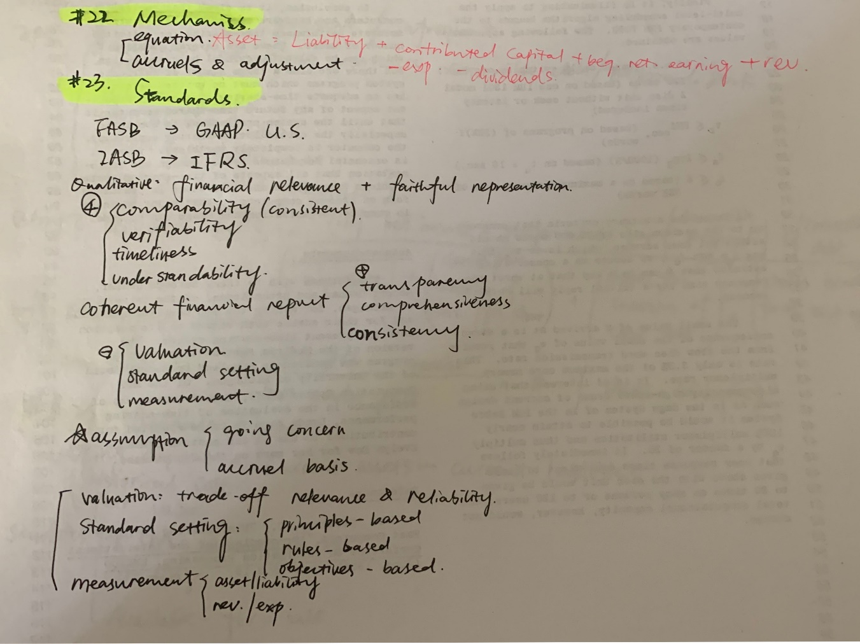

READING 21. UNDERSTANDING INCOME STATEMENTS

  - Describe the components of the income statement and alternative presentation formats of that statement
  - IFRS = GAAP similar: IS com be combined with other comprehensive income in a single one.
  - Net revenue = revenues - adjustments for estimated returns & allowances (aka turnover); Net Income (earnings, or 'bottom line') = revenues - ordinary expenses + other income - other expenses + gains - losses
  - Noncontrolling interest (aka minority interest, minority owner's interest) of subsidiary's inc reported in parents' companies IS, and needs to subtract calculating NI.
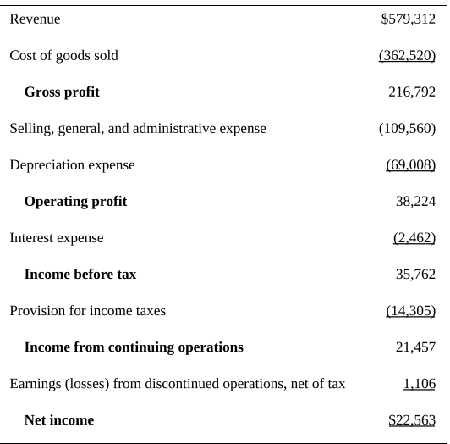
  - Describe general principles of revenue recognition and accounting standards for revenue recognition
  - Calculate revenue given information that might influence the choice of revenue recognition method
Accounting standards - rev recognition, accrual acct, specific applications (accounting for long-term contracts, installment sales, barter transactions, gross and net reporting)
  - IASB revenue: 1. The risk and reward of ownership is transferred. 2. There is no continuing control or management over the goods sold. 3. Revenue can be reliably measured. 4. There is a probable flow of economic benefits. 5. The cost can be reliably measured. AND 1. The amount of revenue can be reliably measured. 2. There is a probable flow of economic benefits. 3. The stage of completion can be measured. 4. The cost incurred and cost of completion can be reliably measured.
  - FASB revenue: 1. realized or realizable, 2. earned; 1. There is evidence of an arrangement between the buyer and seller. 2. The product has been delivered or the service has been rendered. 3. The price is determined or determinable. 4. The seller is reasonably sure of collecting money.
  - Unearned revenue: liability (A/C)
  - Long-term contracts: percentage-of-completion(IFRS, GAAP) & completed-contract(GAPP), when project cannot be reliably estimated, No revenue, expense, or profit would be recognized, IFRS recognize at the end. Loss must be immediately record by IFRS & GAAP. Under IFRS, if the outcome of a project cannot be estimated reliably, revenue and expenses are recognized the same for Y1 (report x expenses and revenue in same amount) over the project’s life but no profit may be recorded until the project is completed.
  - 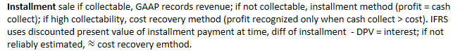
  - Barter transaction (non-monetary exchange, round-trip transaction): GAAP can be recognized at fair value only if historical cash, otherwise carrying value; IFRS must based on fair value from similar non-barter with unrelated parties.
  - Performance obligation: promise to deliver distinct G&S, Transaction price: amount expects to receive in exchange of G&S.
  - Describe general principles of expense recognition, specific expense recognition applications, and implications of expense recognition choices for financial analysis
  - Expenses: amounts incurred to generate rev, COGS (grouping), operating expense, interest, taxes; 1.Cash method 2. Accrual method (matching principle, in same period of revenue incurred)
3.Period costs (eg. Administrative costs) are expenses in the period incurred
  - Gains and losses (economic benefits). Interest expense is usually considered an operating expense for financial firms.
  - 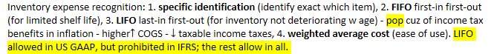
2. accelerated depreciation (recognize more depreciation exp in early years) 3. declining balance method (of constant rate, if no residual value, DB never fully depreciate), double-declining balance
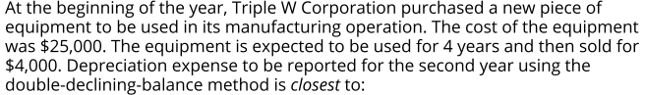
Intangible assets with indefinite lives (e.g., goodwill) are not amortized; however, they must be tested for impairment at least annually; if impaired, impairment amount = expense in IS.
  - Bad debt and warranty expense: matching principle to estimate in the period of sale.
  - Describe the financial reporting treatment and analysis of non-recurring items (including discontinued operations, unusual or infrequent items) and changes in accounting policies
  - Discontinued operation: business must physically and operationally distinct from firm - separate report. Measurement date: formal plan of disposing of operation. Time in between is phaseout period. (estimated loss - accrue during phaseout and sale, expected gain cannot reported until complete sale) Analytical implication: not affect net income, but affect future cash flows.
  - Unusual in nature or infrequent in occurrence items: gain or loss from sale of assets or part of business, which not ordinary operations; impairments, write-offs (of bad debt), write-downs, restructuring costs. Analytical implications: review to decide include or exclude.
  - Extraordinary items: US GAAP material transaction of both unusual and infrequent in occur, reported net of tax, after income from continuing operation, separately in IS; stop after 2015/12/15
  - Changes in accounting principles: from 1 GAAP or IFRS method to another (eg. From LIFO to FIFO), retrospective application. Prior-period adjustments: change of incorrect errors, restated to reflect. Changes in accounting estimates: from management of new info, applied prospectively. Under U.S. GAAP, a firm that changes to LIFO from another inventory cost method does not apply the change retrospectively, but instead uses the carrying value of inventory as the first LIFO layer. Analytical implications: changes not affect cash flows, but in estimate or principles need review to decide impact on future operations; error show weak of internal control.
  - Distinguish between the operating and non-operating components of the income statement
  - For financial firms, investment + financial exp = operating. Non-financial firms, nonoperating include dividends and interest from investment, securities, interest expense of capital structure.
  - Describe how earnings per share is calculated and calculate and interpret a company’s earnings per share (both basic and diluted earnings per share) for both simple and complex capital structures
  - Distinguish between dilutive and antidilutive securities and describe the implications of each for the earnings per share calculation
  - Earnings per share (EPS): most commonly profitability performance for public-traded, shares of common stock(aka ordinary stocks). Simple capital structure contain no potentially dilutive securities, only common stock + nonconvertible debt + nonconvertible preferred stock. Complex capital structure contain potentially dilutive securities(eg. Employee stock options, warrants, or convertible securities). - firms with complex must report basic & diluted EPS, diluted EPS is less than or equal to its basic EPS(always remember to compare).
Payment of a cash dividend on common shares is NOT considered in the calculation of EPS.
  - Stock dividend: distribution of additional shares, eg. 10% means holder of 100 shares receive 10 more shares. Stock split: division of "old" shares into "new"(post-split) shares, create more shares but price drops, eg. 100 shares will 200 shares for 2-for-1 split, and 150 shares for 3-for-2-split. - SO proportional ownership NOT CHANGED, same % of shares outstanding with more shares: a 50% stock dividend and a 3-for-2 stock split both result in three 'new' shares for every two “old” shares.
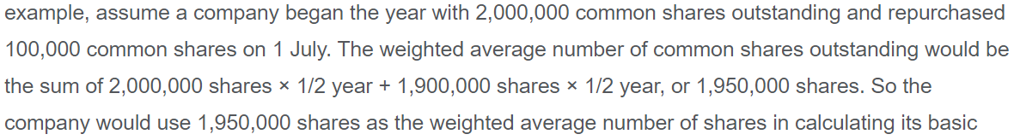
Assuming all other evens the same, a previously declared 2-for-1 stock split took effect. Each shareholder of record receives two shares in exchange for each current share that he or she owns.
For EPS calculation purposes, a stock split is treated as if it occurred at the beginning of the period. The weighted average number of shares would, therefore, be 1,950,000 * 2 = 3,900,000 shares.

  - Reacquired shares excluded from computation from date of reacquisition
  - Shares sold or issued in purchase of assets included
  - Stock split or stock dividend applied to all shares outstanding prior to beginning weighted average shares, but not applied to shares issued or repurchased after split/dividend date.
Dilutive securities |  | Anti-dilutive securities  ↑EPS if exercised or converted to common stock.
If-Converted Method | Treasury Stock Method
convertible debt  (which may be dilutive or antidilutive) | stock options  (which are always dilutive) | `same`
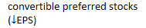 | warrants | `same`

  - If the exercise price is greater than the weighted average market price, the effect of their conversion is anti-dilutive. Any antidilutive effect of a convertible security only relates to the calculation of EPS, antidilutive is not part of the distinction of simple vs. complex capital structure.
  - 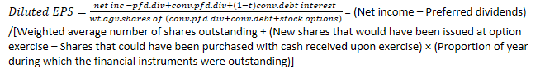
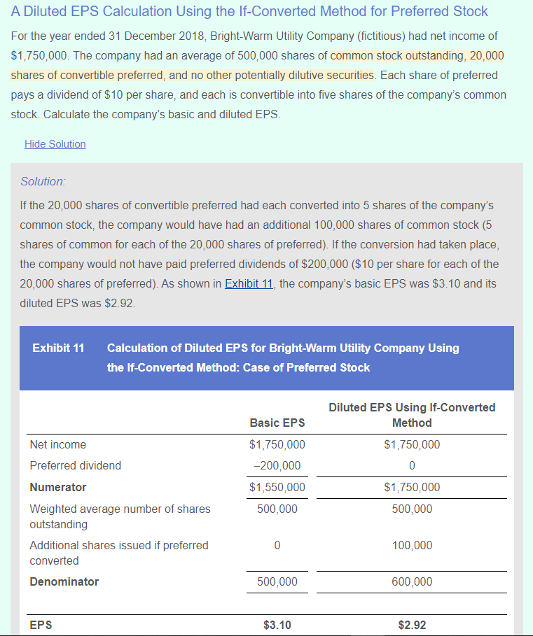
  - A Diluted EPS Calculation Using If-Converted Method for Convertible Debt Company O(fictitious) reported net income of $750,000 for year ended 31 December 2018. The company had a weighted average of 690,000 shares of common stock outstanding. In addition, it has only one potentially dilutive security: $50,000 of 6 percent convertible bonds, convertible into a total of 10,000 shares. Assuming a tax rate of 30 percent, calculate Company O's basic and diluted EPS.
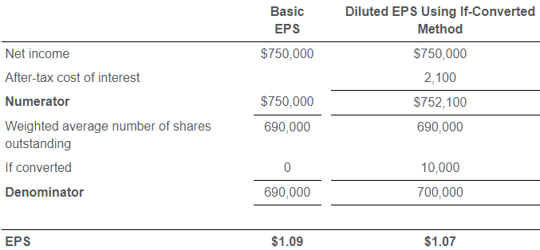
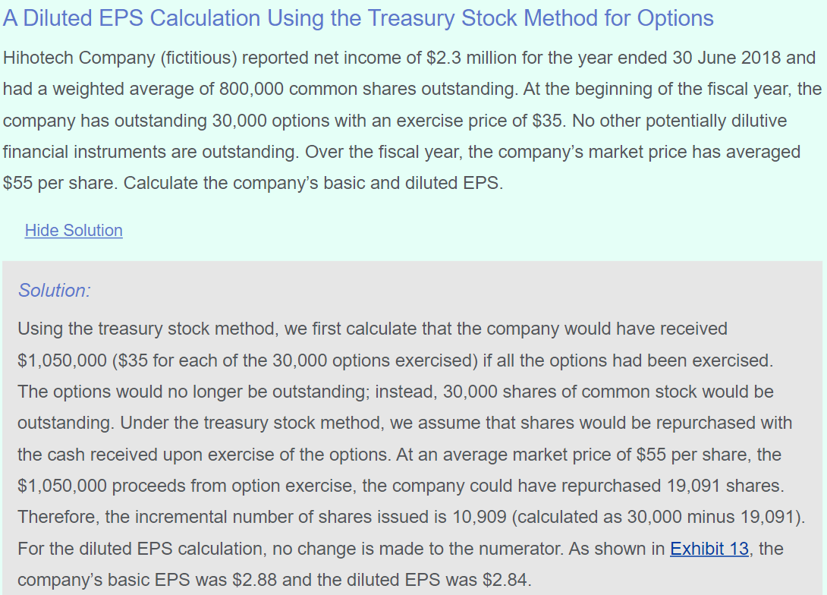
As noted, IFRS require company to consider that any assumed proceeds are received from the issuance of new shares at the average market price for the period. These new “inferred” shares would be disregarded in the computation of diluted EPS, but the excess of the new shares that would be issued under options contracts minus the new inferred shares would be added to the weighted average number of shares outstanding.
Note that this is the same result as that obtained under US GAAP; it is just derived in a different manner. IFRS refer to 19,091 shares the company would have issued at market prices as inferred shares.
  - An Antidilutive Security
For the year ended 31 December 2018, Dim-Cool Utility Company (fictitious) had net income of $1,750,000. The company had an average of 500,000 shares of common stock outstanding, 20,000 shares of convertible preferred, and no other potentially dilutive securities. Each share of preferred pays a dividend of $10 per share, and each is convertible into three shares of the company’s common stock. What was the company’s basic and diluted EPS? - effect of Antidilutive security conversion not included
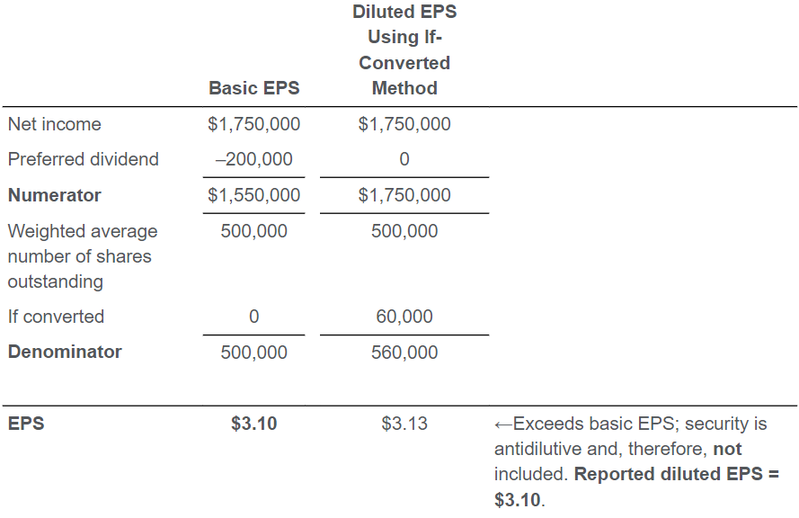
  - Convert income statements to common-size income statements
  - Evaluate a company’s financial performance using common-size income statements and financial ratios based on the income statement
  - A vertical common-size expresses category of income statement as a percentage of revenue. One exception is income tax expense, expressed as a percentage of pretax income; the result known meaningfully as the effective tax rate.
  - Describe, calculate, and interpret comprehensive income
  - Describe other comprehensive income and identify major types of items included in it
  - Anything affects IS (net income) will be added to shareholders' equity - retained earnings. Comprehensive income is a more inclusive measure that includes all changes in equity except for owner contributions and distributions, therefore sum of Net Income + Other comprehensive income:
Comprehensive income = (Ending shareholders equity – Beginning shareholders equity) + Dividends paid
1. Foreign currency translation gains and losses.
2. Adjustments for minimum pension liability.
3. Unrealized gains and losses from cash flow hedging derivatives.
  - 4. Unrealized gains and losses from available-for-sale securities(investment not held to maturity or just sold), realized securities report on BS at fair value, unrealized aren't reported in IS but under share's equity as
other comprehensive income - revenue less expense items excluded from the net income calculation; securities held for trading recognized in net income and NOT OCI.
